# 1. Getting started

ALeP (A Long-extended Party) provides links to MPC (MakePlayingCards) projects so you can print out the packs as they are released. This is the simplest method of printing cards. All you need to do is: create and log into your MPC account, then open the desired ALeP link. You will be brought to a screen that allows you to add the deck to your cart and you’re ready to checkout. The following will guide you through this process.

If you want to customize the deck, please proceed to the next section (2. Customizing the deck). For example, you might want to combine several packs together, add additional copies of some player cards, etc.

* Open [**http://www.makeplayingcards.com**](http://www.makeplayingcards.com) and click **Sign In**.

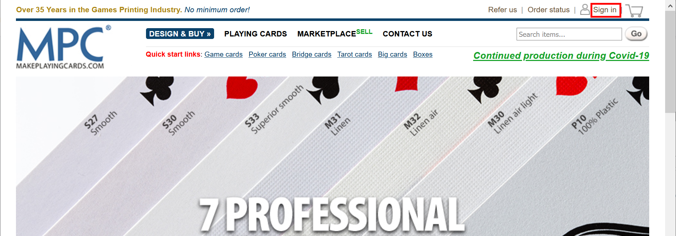

* If you already have an account, enter your credentials, and click **Login** button. Otherwise, choose whether you want to **register** or just login using **Facebook** or **Google**.

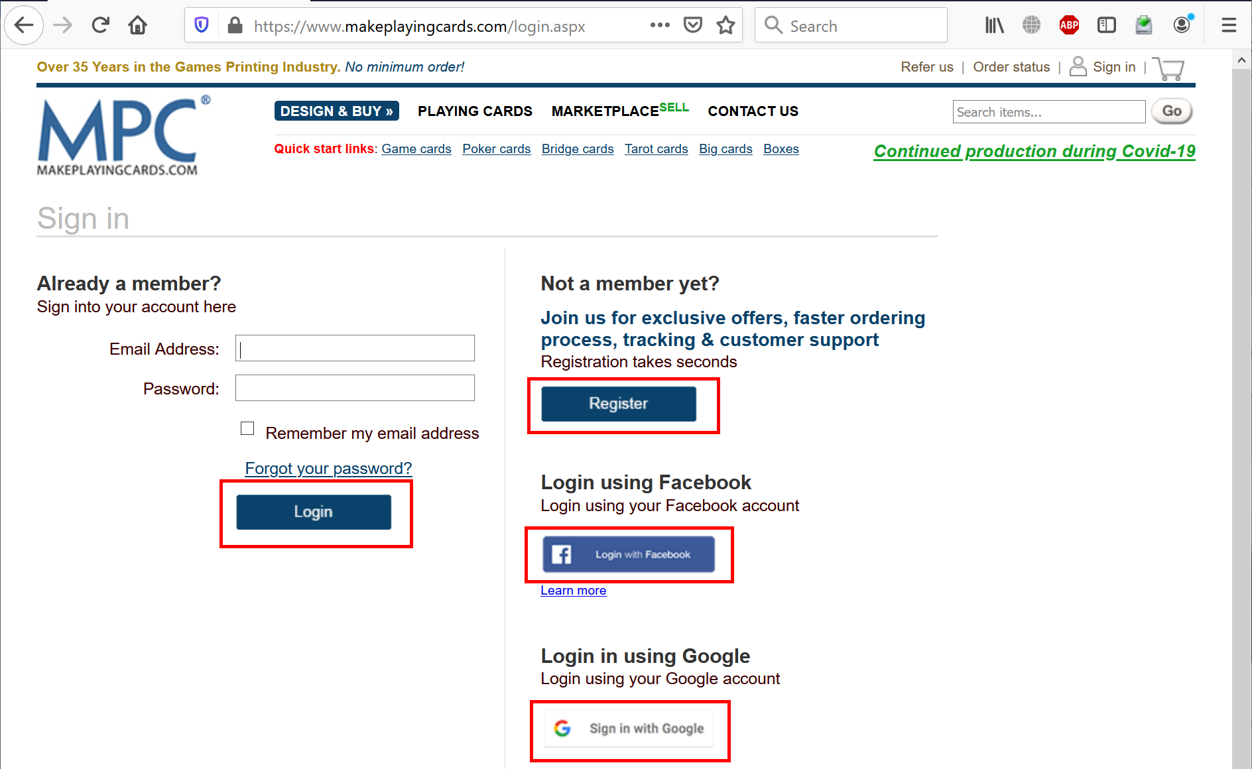

* Once you logged in, open a direct ALeP link. You will see all the cards in that deck.
* Select **Yes, I confirm that all the images…** checkbox at the bottom of the page and click **Add to Cart** button.

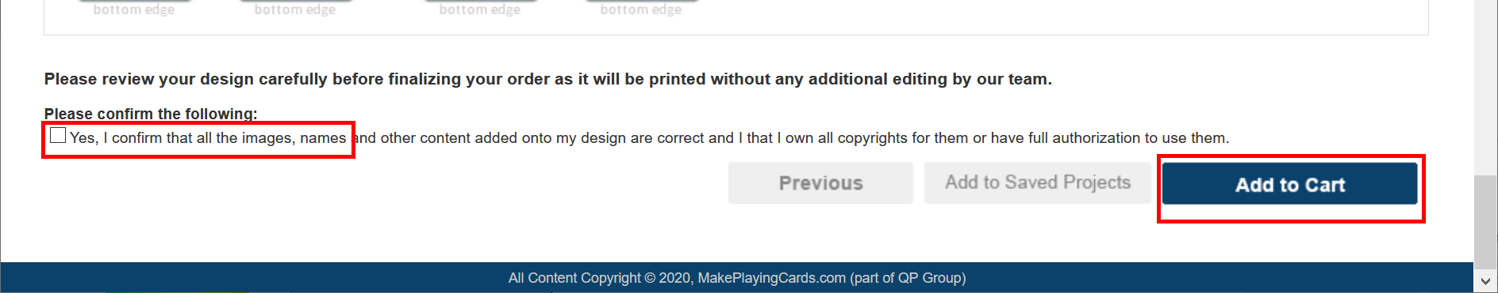

* If needed, update **Quantity**.

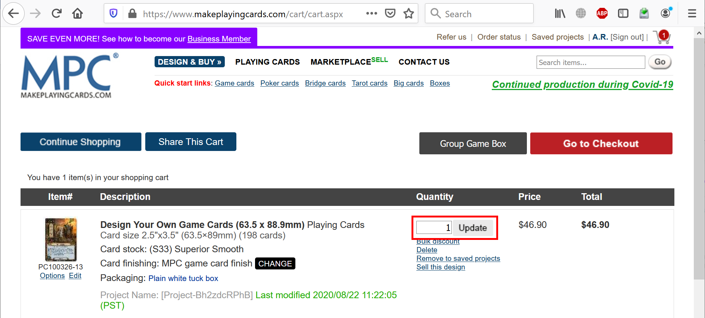

* Scroll to the bottom and click **Go to Checkout** button.

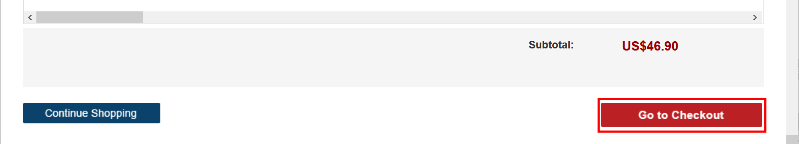

* Specify **Billing Address**, **Shipping Address**, **Shipping Method**, **Payment** details and click **Submit Order** button.

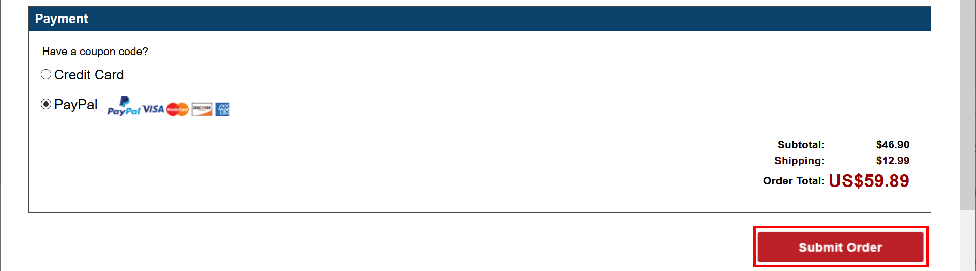

# 2. Customizing the deck

If you want to customize the deck, download either **7z** or **zip** archive for **MakePlayingCards** from ALeP web-site (make sure that its name starts with **“MPC”**). Extract files from the archive. It contains two folders: **front** and **back**. Do all the required customizations (add or remove cards, etc.) Make sure that all images are in **RGB PNG** format and have correct size (3.74 in x 2.74 in).

If you want to share this deck, please proceed to the next section (3. Creating a new shared URL).

* Open [**http://www.makeplayingcards.com**](http://www.makeplayingcards.com) and click **Sign In**.



* If you already have an account, enter your credentials, and click **Login** button. Otherwise, choose whether you want to **register** or just login using **Facebook** or **Google**.



* Once you logged in, open this direct link:

[**https://www.makeplayingcards.com/design/custom-blank-card-traditional-size.html**](https://www.makeplayingcards.com/design/custom-blank-card-traditional-size.html).

* Choose **Card stock**: either **(S30) Standard Smooth** (slightly cheeper, moderate quality) or

**(S33) Superior Smooth** (highly recommended, slightly more expensive, higher quality).

* Choose correct **Size of deck**. For the Children of Eorl Deluxe it’s **Up to 198 cards**.
* Choose **Packaging**. We suggest **Plain white tuck box**, but you may consider other options as well.
* Leave the rest of dropdowns without changes:
* **Print type**: Full color print
* **Finish**: MPC game card finish
* **Wrapping**: Shrink-wrapped
* **Booklets**: None
* Click **start your design** button.

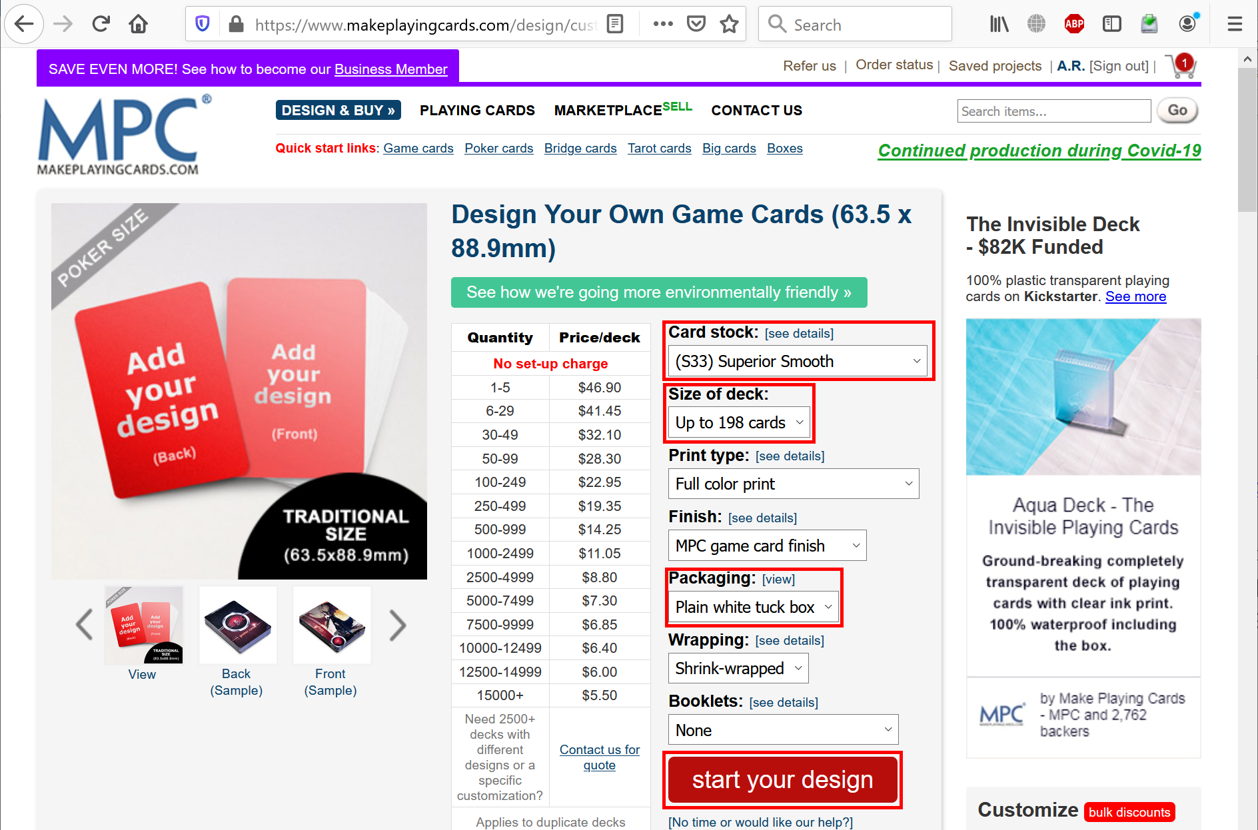

* Click **Different images** button.

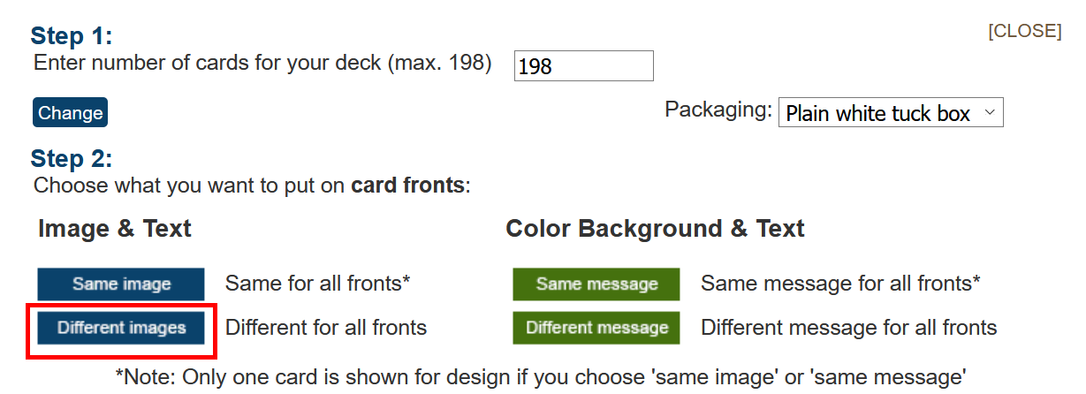

* Click **Upload images** button.

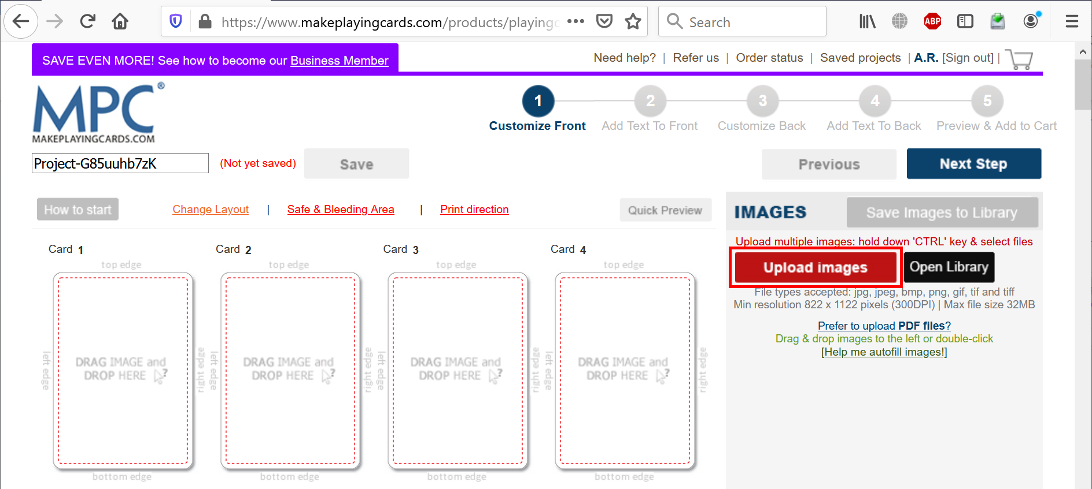

* Navigate to your **front** folder, select allimage files, and click **Open**. Wait until all images have been uploaded (depending on your Internet connection speed, this may take a while).
* Click **Help me autofill images!** and wait until all images have been placed into the area at the left.

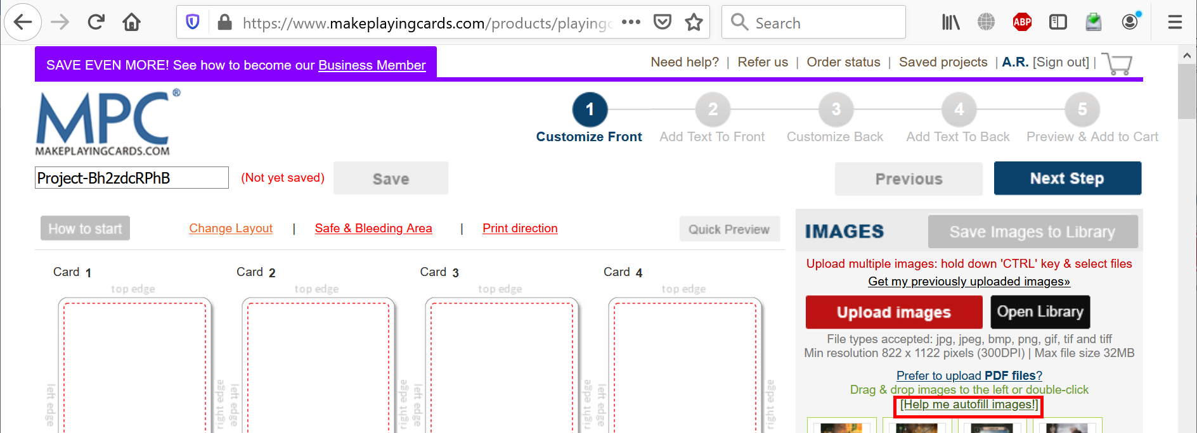

* Double-check that all cards have been placed, then click **Next Step** button.

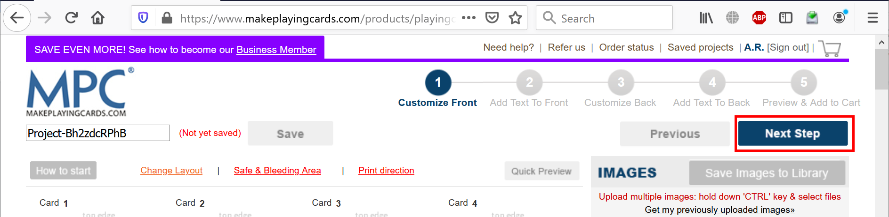

* Dismiss a help popup if any, don’t change anything and click **Next Step** button.

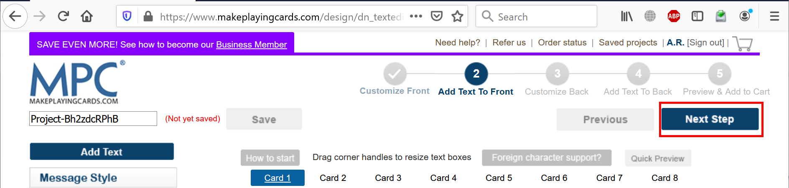

* Click **Different images** button.

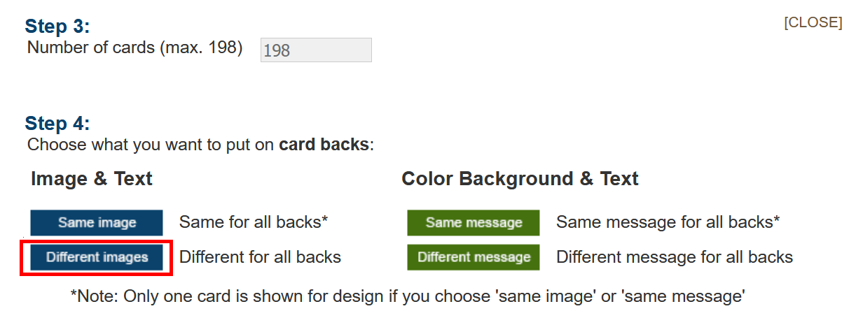

* Repeat for the back cards: click **Upload images** button, navigate to your **back** folder, select allimage files, and click **Open**. Wait until all images have been uploaded, click **Help me autofill images!** and wait until all images have been placed into the area at the left. When done, click **Next Step** button.

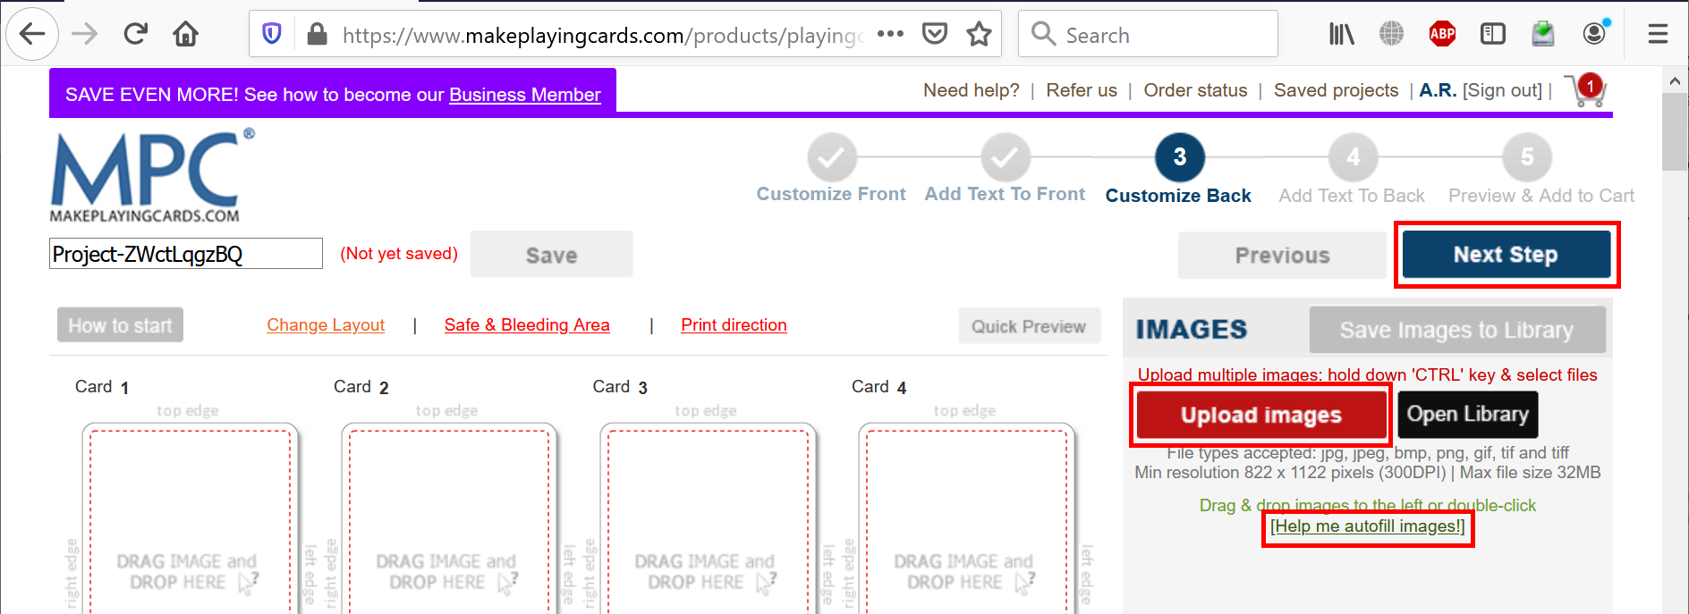

* Don’t change anything and click **Next Step** button again.

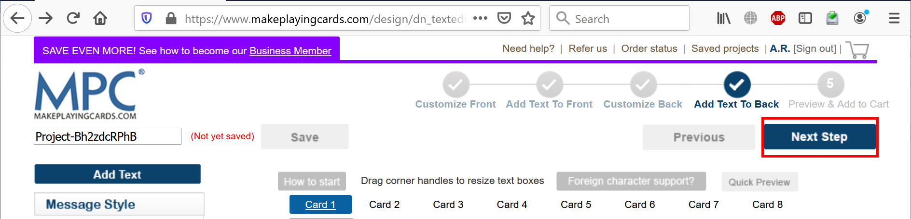

* Carefully review front and back sides of all cards. When finished, select **Yes, I confirm that all the images…** checkbox at the bottom of the page and click **Add to Cart** button.



* If needed, update **Quantity**.



* Scroll to the bottom and click **Go to Checkout** button.



* Specify **Billing Address**, **Shipping Address**, **Shipping Method**, **Payment** details and click **Submit Order** button.



# 3. Creating a new shared URL

If you have created a new deck and you want to share it, follow the steps below.

* Go to **Saved projects**.

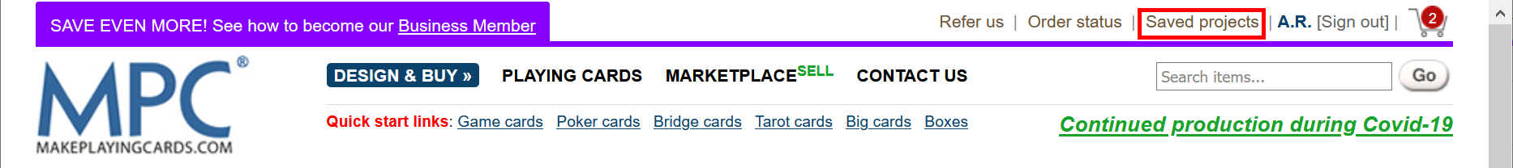

* If your deck is still in the cart and not saved to the projects yet, then either finish your order or just click **Remove to saved projects**.

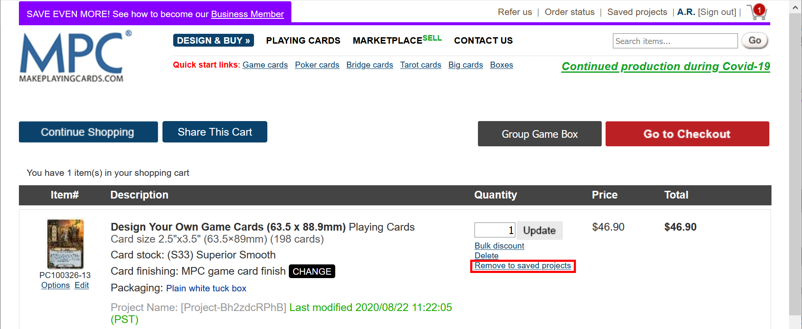

* Find the deck in the saved projects, right-click the checkbox to the left of the deck and click **Inspect** (Google Chrome) or **Inspect Element** (Firefox, Safari, Microsoft Edge).

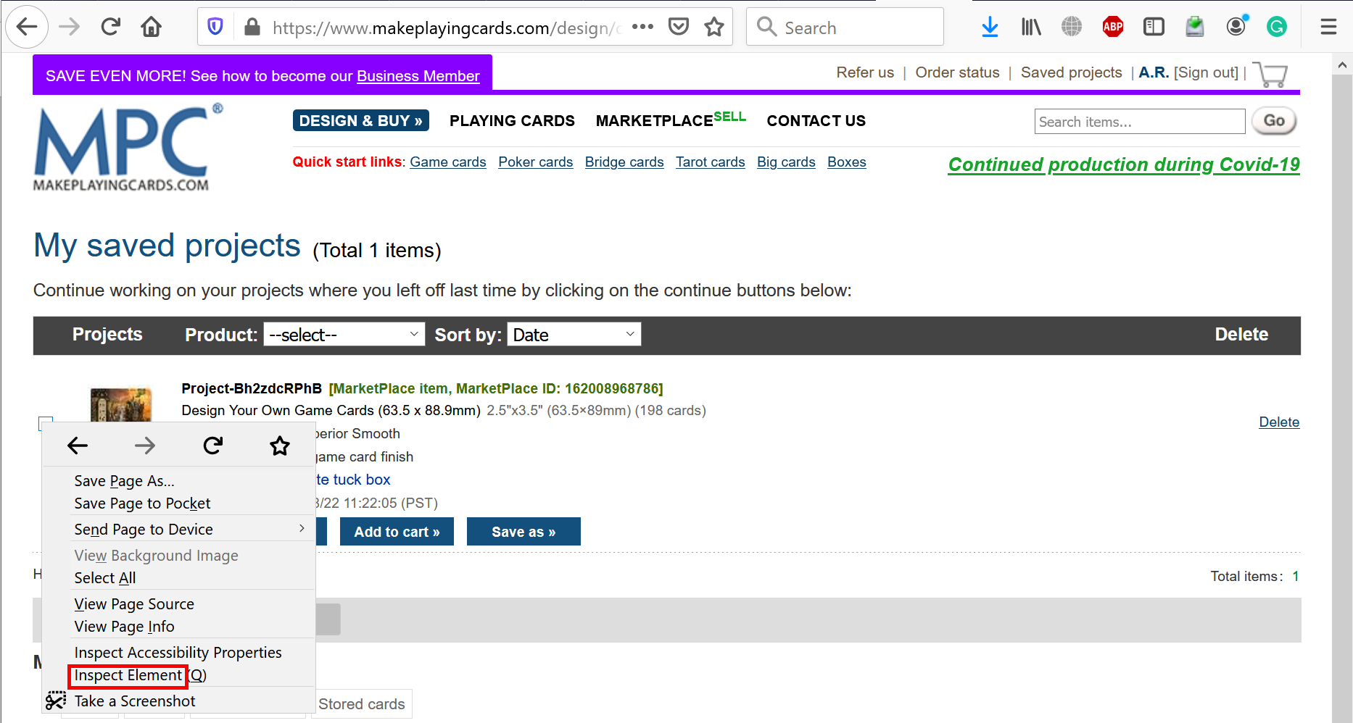

* You will see the source code. Copy a long ID of the input element without “chk_” prefix.

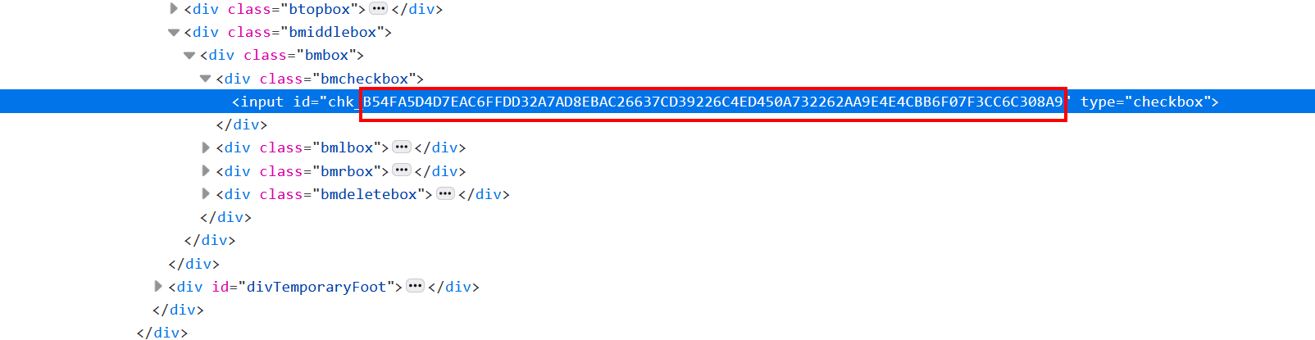

* Construct the following URL:

**https://www.makeplayingcards.com/design/dn_temporary_parse.aspx?id=<your long ID>**

* Now you can share this URL to anybody (they must be logged in).